**Project Report**

**Student Details**

**Name:** Chirantan Dey  
**Roll Number:** 23f2001382  
**Course:** Data Science and Applications  
**Email**: 23f2001382@ds.study.iitm.ac.in

**Project Details**

**Question Statement**

Develop a web-based application platform that allows sponsors to create advertising campaigns and connect with influencers who have a significant social media following. The application will have three roles: Admin, Sponsor, and Influencer. Admins have root access and can monitor all activities, Sponsors can create campaigns and manage ad requests, and Influencers can manage their profiles and negotiate ad requests.

**Approach to Problem Statement**

1. **Requirement Gathering:** Analyzed the requirements and identified the core functionalities needed for each role (Admin, Sponsor, Influencer).
2. **Design:** Created an ER diagram to model the database, and wireframes to visualize the user interfaces and interactions.
3. **Development:** Used Flask for application logic, Jinja2 templates and Bootstrap for the frontend, and SQLite for the database.
4. **Deployment:** Deployed the application locally for demonstration purposes.

**Frameworks and Libraries Used**

* **Flask:** For building the application backend and handling routing.
* **Jinja2:** For rendering HTML templates.
* **Bootstrap:** For styling and responsive design.
* **SQLite:** For database management.
* **WTForms:** For handling form data and validation.
* **Flask-Bcrypt:** For hashing passwords.
* **Flask-Login:** For managing user sessions.

**ER Diagram**

The ER diagram below illustrates the relationships between different entities in the database:

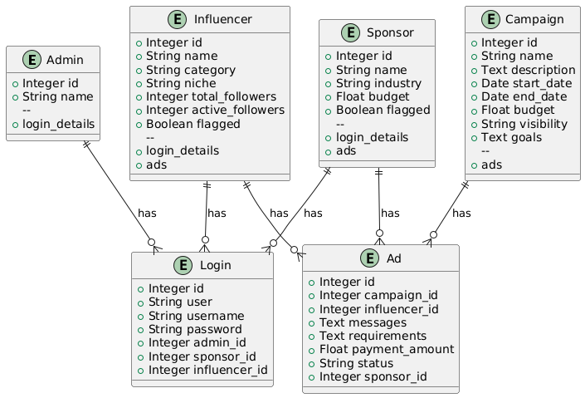

**API Resource Endpoints**

**Admin Endpoints**

* **GET /admin/dashboard:** Display all statistics and flagged users/campaigns.
* **POST /flag_user:** Flag or unflag a sponsor or influencer.

**Sponsor Endpoints**

* **GET /sponsor/dashboard:** Display sponsor-specific information.
* **POST /sponsor/create_campaign:** Create a new campaign.
* **POST /sponsor/update_campaign:** Update an existing campaign.
* **POST /sponsor/delete_campaign:** Delete a campaign.
* **POST /sponsor/create_ad_request:** Create a new ad request.
* **POST /sponsor/update_ad_request:** Update an existing ad request.
* **POST /sponsor/delete_ad_request:** Delete an ad request.
* **GET /sponsor/search_influencers:** Search for influencers based on criteria.

**Influencer Endpoints**

* **GET /influencer/dashboard:** Display influencer-specific information.
* **POST /influencer/update_profile:** Update influencer profile.
* **GET /influencer/search_campaigns:** Search for public campaigns.
* **POST /influencer/create_ad_request:** Accept, reject, or negotiate an ad request.

**Video:**

https://youtu.be/Ncx1tEVQbMQ

https://drive.google.com/file/d/1rVGEDvwElfFwuLRmeqSFswk17gHvr3-t/view?usp=sharing